

UNIVERSITY OF PETROLEUM AND ENERGY STUDIES, DEHRADUN

PedestriGuard AI – Intelligent Pedestrian Detection and Behavior Analysis System

Synopsis Report of the (Major Project - 2) in Semester VIII

S. No | Name | Roll Number | Sap ID
1. | ANSHUMAN AGARWAL | R2142221543 | 500125828
2. | ADIT JAIN | R2142221275 | 500101867
3. | PARITOSH DHINGRA | R2142220747 | 500107374
4. | MUKESH SIHAG | R2142221075 | 500108266

BACHELOR OF TECHNOLOGY, COMPUTER SCIENCE ENGINEERING
With specialization in AI&ML

Under the guidance of
M/s Vinamrata Rani

School of Computer Science (SOCS), AIML Cluster, UPES Bidholi Campus, Energy Acres, Dehradun – 248007

INDEX

S.NO | CONTENT | PAGE
1 | INTRODUCTION | 3
2 | ABSTRACT | 4
3 | LITERATURE REVIEW | 6
4 | PROBLEM STATEMENT | 8
5 | OBJECTIVE | 8
6 | METHODLOGY | 9
7 | AREA OF APPLICATION | 11
8 | PERT CHART | 12
9 | SWOT ANALYSIS | 12
10 | CONCLUSION | 13
11 | REFERENCES | 13

INTRODUCTION
In today’s rapidly evolving urban landscape, ensuring pedestrian safety has become more important than ever. With increasing traffic density, smart city development, surveillance expansion, and the growth of autonomous systems, monitoring pedestrian movement is no longer just about counting people — it is about understanding them. Cities require intelligent systems that can not only detect pedestrians but also interpret their behavior, identify potential risks, and provide meaningful insights in real time.
Traditional vision-based surveillance systems primarily focus on basic object detection. While they can identify the presence of a pedestrian, they often fail in complex real-world situations such as crowded streets, partially occluded views, poor lighting conditions, or dynamic environments. Moreover, these systems lack the ability to analyze behavior, detect emergencies like falls, or provide demographic insights. In modern smart infrastructure, such limitations reduce their effectiveness and reliability.
To address these challenges, PedestriGuard AI – Intelligent Pedestrian Detection and Behavior Analysis System has been designed as a comprehensive and next-generation solution. Unlike conventional systems, PedestriGuard AI does not stop at detection; it goes several steps further by combining advanced computer vision techniques with deep learning algorithms to build an intelligent and adaptive pedestrian monitoring framework.
PedestriGuard AI performs high-precision pedestrian detection across diverse environmental conditions. Whether it is a busy urban intersection, a shopping mall, a railway station, or a surveillance camera feed in low-light scenarios, the system is trained to reliably identify pedestrians with high accuracy.
Beyond detection, the system enables persistent tracking and monitoring, maintaining pedestrian identity across multiple frames and even across different camera views. This ensures continuity in surveillance and avoids identity confusion in crowded scenes.
One of the most powerful aspects of PedestriGuard AI is its behavior analysis capability. The system can recognize common pedestrian activities such as walking, running, standing, and sudden unusual movements. Most importantly, it is capable of detecting critical incidents such as falls, which can be extremely valuable in environments like elderly care centers, public transport hubs, and high-risk urban areas. Real-time behavioral insights allow authorities or automated systems to respond immediately to potential emergencies.
In addition to activity recognition, PedestriGuard AI incorporates demographic estimation features, providing analytical insights into age groups and gender distribution. Such information can assist urban planners, security agencies, and commercial establishments in making data-driven decisions.
A significant technical strength of the system lies in its robustness against occlusion and crowd density. In real-world environments, pedestrians are often partially hidden by other individuals or objects. PedestriGuard AI utilizes advanced attention mechanisms and data augmentation strategies to ensure reliable performance even in dense and complex scenarios.
The primary objective of this project is to develop a scalable, efficient, and intelligent pedestrian monitoring system that can seamlessly integrate into smart city infrastructure, surveillance networks, and autonomous mobility platforms. By combining detection, tracking, behavioral understanding, and demographic analysis into a unified architecture, PedestriGuard AI aims to contribute toward building safer, smarter, and more responsive urban ecosystems.
Ultimately, PedestriGuard AI represents a step forward in intelligent surveillance — transforming traditional monitoring systems into proactive, analytical, and human-centered safety solutions.

ABSTRACT

PedestriGuard AI is an advanced, AI-powered intelligent surveillance system designed to deliver comprehensive pedestrian intelligence from real-time video streams. Unlike traditional monitoring systems that focus only on basic pedestrian detection, PedestriGuard AI goes beyond surface-level analysis by integrating multiple deep learning modules to create a unified, intelligent framework capable of detection, tracking, behavioral interpretation, and demographic estimation.

The system combines state-of-the-art computer vision technologies to ensure high accuracy and real-time responsiveness. It incorporates advanced object detection models such as YOLOv8 for precise pedestrian identification, DeepSORT for consistent multi-object tracking, and pose estimation frameworks like HRNet to understand body posture and movement patterns. By integrating these components, PedestriGuard AI can not only detect pedestrians but also maintain identity continuity across frames and cameras, even in crowded or partially occluded environments.

A key highlight of PedestriGuard AI is its behavior analysis capability. The system can recognize everyday activities such as walking, running, and standing, while also detecting critical events such as falls in real time. This feature is particularly valuable in high-risk environments such as elderly care facilities, public transportation hubs, and smart surveillance networks where immediate response is crucial.
In addition to behavioral understanding, the system performs demographic estimation, including approximate age group classification and gender prediction. These insights provide valuable analytical data for urban planning, public safety management, healthcare monitoring, and retail intelligence.

PedestriGuard AI addresses several major limitations of conventional surveillance systems. It is designed to operate effectively in complex and dynamic environments where challenges such as crowd density, occlusion, varying lighting conditions, and motion blur are common. Through attention mechanisms, robust training strategies, and model optimization techniques, the system maintains reliable performance under real-world constraints.
To ensure scalability and real-time deployment, the system is optimized using frameworks such as TensorRT and ONNX, enabling efficient inference on edge devices and GPU-based systems. The project follows an incremental development model, allowing modular improvements and easy integration into existing smart infrastructure.

The potential applications of PedestriGuard AI extend across multiple domains, including smart cities, autonomous vehicles, intelligent traffic management systems, public safety surveillance, healthcare monitoring, and retail analytics. By transforming raw video data into actionable intelligence, PedestriGuard AI enhances situational awareness, improves public safety outcomes, and supports data-driven decision-making.

In essence, PedestriGuard AI represents a forward-looking step in intelligent surveillance — combining detection, tracking, behavioral insight, and demographic analysis into a powerful and practical real-time pedestrian intelligence system.

LITERATURE REVIEW

The field of pedestrian detection and behavior analysis has evolved significantly over the past decade, driven by advancements in deep learning and computer vision. Researchers have contributed innovative solutions addressing individual components such as detection, tracking, pose estimation, and fall detection. However, despite remarkable progress, a fully unified and real-time deployable framework remains limited. The following review highlights key contributions and identifies the research gap that motivates the development of PedestriGuard AI.

[1] Zhang Shanshan et al. – Deep Learning-Based Pedestrian Detection
Early deep learning research established Convolutional Neural Networks (CNNs) as the new standard for pedestrian detection. Zhang and colleagues demonstrated how CNN-based architectures significantly improved detection accuracy compared to traditional handcrafted feature methods.
However, their work also highlighted persistent challenges such as:
- Handling occlusion in crowded scenes
- Managing scale variation (small and distant pedestrians)
- Performance degradation in complex urban environments
These limitations indicate that detection alone is insufficient for real-world deployment in dynamic city scenarios.

[2] Nicolai Wojke et al. – DeepSORT
The introduction of DeepSORT (Simple Online and Realtime Tracking with a Deep Association Metric) marked a major advancement in multi-object tracking. By integrating motion prediction (via Kalman filtering) with deep appearance descriptors, the method significantly reduced identity switches and improved tracking consistency.
DeepSORT made pedestrian tracking more reliable, particularly in surveillance settings. However, it focused primarily on tracking accuracy rather than higher-level behavior understanding or demographic analysis.

[3] Zhe Cao et al. – OpenPose
The development of OpenPose revolutionized pose estimation by enabling real-time multi-person keypoint detection. This work laid the foundation for advanced behavioral analytics by providing accurate skeletal representations of human posture.
Pose estimation opened doors for:
- Activity recognition
- Gesture analysis
- Fall detection systems
While highly effective, OpenPose-based systems often operate as standalone modules and are not deeply integrated with detection and tracking frameworks.

[4] Liang Zheng et al. – Person Re-Identification in the Wild
Zheng’s work addressed the complex challenge of recognizing individuals across non-overlapping camera views, a problem critical for city-scale surveillance systems. Person re-identification (Re-ID) techniques improved cross-camera tracking capabilities.
Despite this advancement, large-scale implementations often struggle with computational efficiency and real-time deployment constraints, particularly in dense urban environments.

[5] Li Wei et al. – Fall Detection Using Pose Estimation
Research in fall detection shifted from motion-based or shape-based methods to pose-keypoint-based approaches, which demonstrated significantly improved accuracy. By analyzing skeletal posture changes, fall detection became more robust and less dependent on environmental factors.
However, many such systems were designed specifically for healthcare monitoring and were not integrated into broader pedestrian intelligence frameworks.

[6] Brandão – Age and Gender Bias in Detection Algorithms
Brandão’s research revealed an important ethical issue: pedestrian detection models often exhibit demographic bias, showing higher error rates for certain groups such as children or elderly individuals. This highlights the necessity for inclusive model training and balanced datasets.
The study emphasizes that intelligent surveillance systems must not only be accurate but also fair and unbiased.

Identified Research Gap:
From the literature, it is evident that substantial progress has been achieved in individual components:
- High-accuracy pedestrian detection
- Multi-object tracking
- Pose estimation for behavior analysis
- Person re-identification across cameras
- Fall detection systems
- Bias analysis in demographic estimation

However, most existing solutions function as independent modules rather than a seamlessly integrated system. There is a lack of a unified framework that:
- Combines detection, tracking, re-identification, and pose-based behavior analysis
- Incorporates demographic estimation responsibly
- Handles occlusion and crowd density robustly
- Optimizes performance for real-time deployment
- Ensures scalability for smart city infrastructure

PROBLEM STATEMENT

Existing pedestrian detection systems focus mainly on basic detection and lack integrated tracking, behavior analysis, and demographic insights. They perform poorly in crowded or occluded environments and operate as fragmented solutions. Therefore, a unified, real-time intelligent pedestrian monitoring system is required.

OBJECTIVE

The primary objectives of the PedestriGuard AI project are:

- To develop a robust and accurate pedestrian detection system capable of performing effectively in complex real-world environments, including crowded and occluded scenarios.
- To implement a reliable tracking and re-identification mechanism that maintains consistent pedestrian identities across video frames and multiple camera views.
- To integrate pose estimation and activity recognition for classifying pedestrian actions such as walking, running, and standing, along with detecting critical events like falls in real time.
- To incorporate demographic insight analysis for estimating pedestrian age groups and gender to support context-aware decision-making.
- To design and deploy a unified, optimized, and scalable intelligent system suitable for applications in smart surveillance, autonomous systems, and urban safety management.

METHODOLOGY

The development of PedestriGuard AI follows the Incremental Development Model, as it allows systematic integration of multiple complex AI modules while enabling continuous testing and refinement at each stage. Since the project involves detection, tracking, behavior analysis, and demographic estimation, an incremental approach ensures better stability, performance validation, and scalability.

Technical Methodology:

1. Data Collection and Preprocessing
To ensure robustness and generalization, the system is trained using well-established public datasets such as:
- COCO (Common Objects in Context)
- CityPersons
- MOTChallenge
These datasets provide diverse pedestrian scenarios, including crowded environments, varying lighting conditions, and occlusions.
Data preprocessing techniques such as normalization, resizing, and augmentation (random flipping, scaling, brightness adjustment, and noise injection) are applied to enhance model robustness and real-world adaptability.

2. Model Selection and Training
To achieve a holistic pedestrian intelligence system, specialized deep learning models are selected for each functional module:
- Detection Module:
The pedestrian detection component is built by fine-tuning YOLOv8 on pedestrian-specific datasets to achieve high accuracy and real-time performance.
- Tracking Module:
Multi-object tracking is implemented using DeepSORT, integrated with a custom-trained Re-Identification (Re-ID) network to maintain consistent pedestrian identities across frames and camera views.
- Pose Estimation and Behavior Analysis:
HRNet is used for extracting precise human keypoints. These pose sequences are then fed into temporal models such as LSTM or Transformer networks to classify activities (walking, running, standing) and detect abnormal events like falls.
- Demographic Estimation Module:
A multi-task Convolutional Neural Network (CNN) classifier is trained to estimate age group and gender simultaneously, enabling contextual pedestrian analytics.

3. System Integration
All modules are integrated into a modular pipeline developed in Python using frameworks such as OpenCV and PyTorch / TensorFlow.
The architecture is designed such that:
- Detection outputs serve as inputs for tracking
- Tracking outputs feed into pose estimation
- Pose sequences are passed to behavior analysis
- Demographic estimation runs parallelly on detected pedestrian regions
This modular yet interconnected structure ensures flexibility, maintainability, and scalability.

4. Optimization and Deployment
To achieve real-time inference, trained models are converted to ONNX format and optimized using TensorRT.
This optimization significantly reduces latency and enables deployment on GPU-enabled systems and edge devices for smart city applications.

5. Evaluation Metrics
The performance of PedestriGuard AI is evaluated using standard benchmarks:
- mAP (Mean Average Precision) for pedestrian detection accuracy
- MOTA (Multiple Object Tracking Accuracy) for tracking performance
- Classification Accuracy for activity and demographic estimation
- F1-Score for fall detection reliability
Through this structured methodology, PedestriGuard AI ensures accuracy, robustness, scalability, and real-time efficiency, making it suitable for practical deployment in intelligent surveillance and smart urban environments.

AREA OF APPLICATION
PedestriGuard AI has wide-ranging applications across multiple real-world domains where pedestrian understanding and safety are critical:
- Smart Cities: Enables real-time pedestrian monitoring for traffic flow optimization, enhanced safety at intersections, crowd density analysis, and effective management of large public events.
- Surveillance and Security: Supports intelligent surveillance in public spaces such as malls, airports, and railway stations by providing proactive anomaly detection, fall detection, and behavior-based alerts.
- Autonomous Vehicles: Acts as a reliable perception layer for self-driving and assisted-driving systems, ensuring safe navigation in urban environments through accurate pedestrian detection, tracking, and movement prediction.
- Healthcare and Elderly Care: Facilitates remote monitoring in hospitals, care homes, and private residences with instant alerts for falls and abnormal activities, improving response time and patient safety.
- Retail Analytics: Provides actionable insights through demographic and footfall analysis, including age group and gender distribution, helping retailers optimize store layout, staffing, and marketing strategies.

- PERT CHART
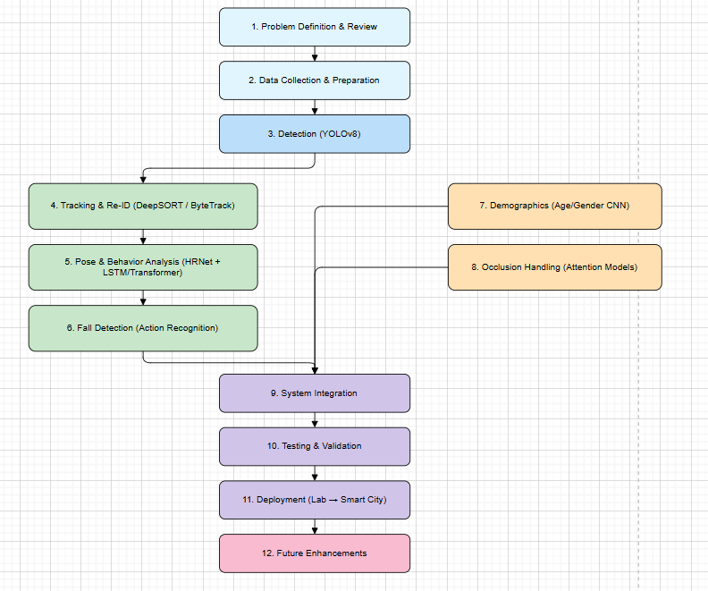

- SWOT ANALYSIS

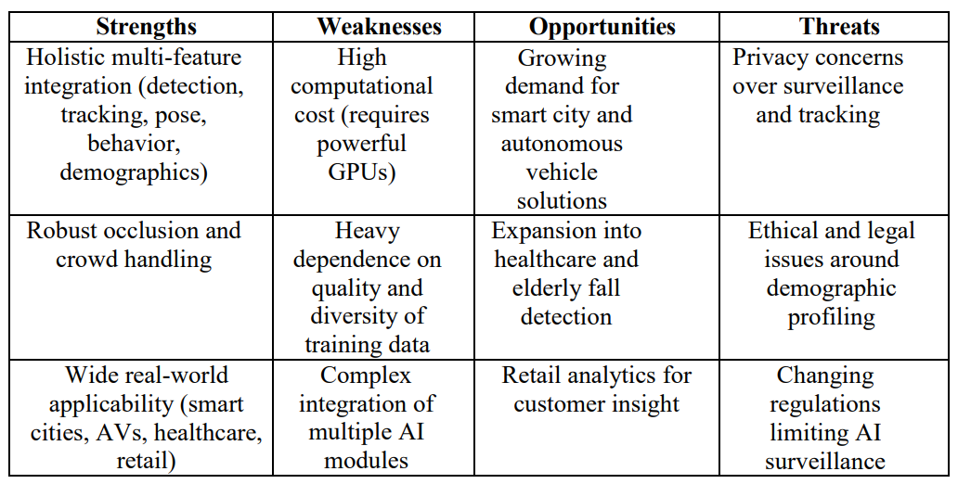
- CONCLUSION

PedestriGuard AI presents a comprehensive and integrated approach to overcoming the limitations of conventional pedestrian monitoring systems. By combining advanced models for detection, tracking, pose estimation, behavior recognition, and demographic analysis into a unified framework, the system delivers deeper contextual understanding and practical real-world applicability.

The incremental development strategy ensures systematic integration, continuous validation, and improved reliability at every stage of implementation. While challenges such as computational requirements and ethical considerations must be carefully addressed, the overall impact of the system is highly promising.

PedestriGuard AI has the potential to significantly enhance public safety, improve operational decision-making, and support intelligent urban infrastructure. Ultimately, this project contributes toward building smarter, safer, and more responsive cities by laying a strong technological foundation for next-generation surveillance and autonomous systems.

REFRENCES
[1] Redmon, J., & Farhadi, A. (2018). YOLOv3: An Incremental Improvement. arXiv preprint arXiv:1804.02767.
[2] Wojke, N., Bewley, A., & Paulus, D. (2017). Simple Online and Realtime Tracking with a Deep Association Metric (DeepSORT). Proceedings of IEEE International Conference on Image Processing (ICIP).
[3] Cao, Z., Simon, T., Wei, S. E., & Sheikh, Y. (2017). Realtime Multi-Person 2D Pose Estimation using Part Affinity Fields. Proceedings of IEEE Conference on Computer Vision and Pattern Recognition (CVPR).
[4] Zhang, S., Benenson, R., Schiele, B. (2017). Deep Learning for Pedestrian Detection: A Comprehensive Survey. IEEE Transactions on Pattern Analysis and Machine Intelligence (TPAMI).
[5] Brandão, M. (2019). Age and Gender Bias in Pedestrian Detection Algorithms. Research Study on Fairness in Computer Vision Systems.

